PROJECT OUTPUTS
COMPUTER NETWORKS-24CS2202

Campus Lost and Found

BACHELOR OF TECHNOLOGY
In
DEPARTMENT OF COMPUTER SCIENCE AND INFORMATION TECHNOLOGY
By

ARUGUNTA SHARVANI – 2420090052

MUPPALA VINUSHA --2420030212
Cluster:3 Section:11
Under the Esteemed Guidance of
Ms. Chandusha
Assistant Professor, Dept of CSE



Koneru Lakshmaiah Education Foundation (Deemed to be Universityestd. u/s. 3 ofthe UGC Act,1956)
Off-Campus:Bachupally-Gandimaisamma Road,Bowrampet,Hyderabad,Telangana-500 043. www.klh.edu.in



Screen shorts:

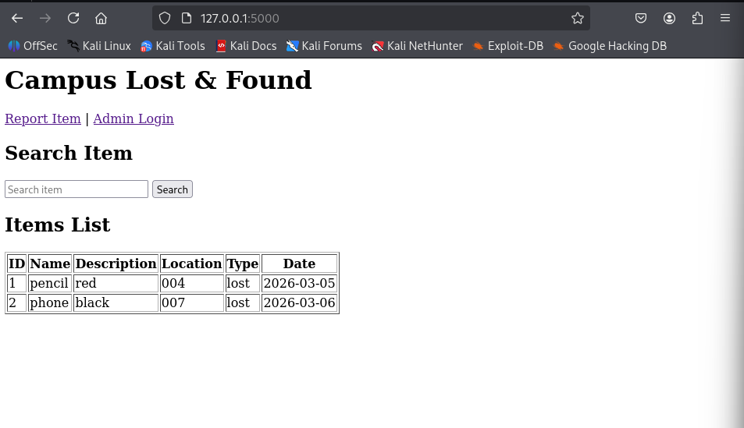

The home page of the application displays all the lost and found items stored in the database. It includes a navigation menu with links to Report Item and Admin Login. A search bar is provided to allow users to filter items based on keywords such as item name.

The data is retrieved from the database using SQL queries and displayed in a tabular format. Each record contains item ID, name, description, location, type, and date. This page demonstrates the integration of frontend and backend through HTTP request-response communication.

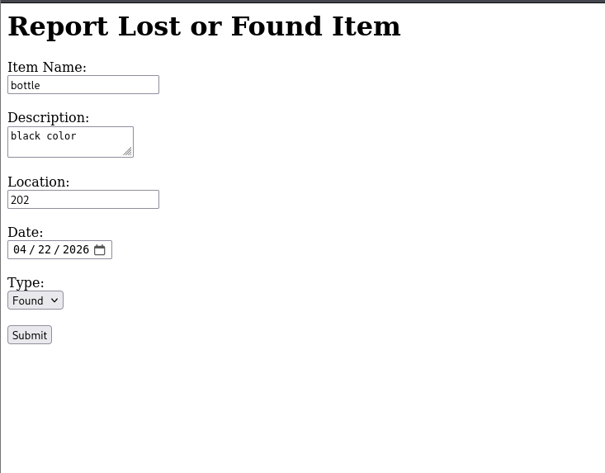

This page provides a form for users to report lost or found items. The user is required to enter details such as item name, description, location, date, and type (lost or found). The form uses the POST method to send data to the Flask server.

After submission, the server processes the input and stores the data in the SQLite database. This page demonstrates how user input is collected and transmitted securely to the backend.

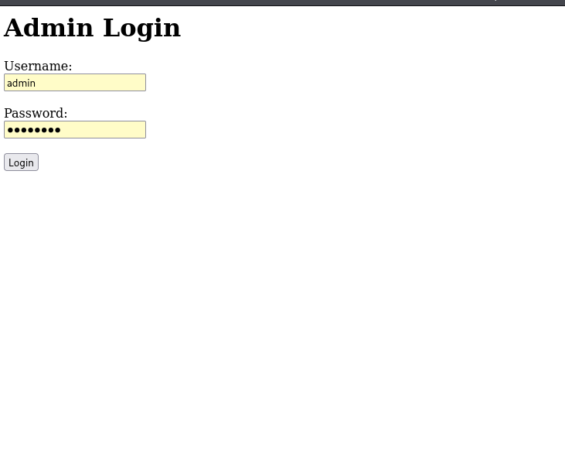

The admin login page provides authentication for accessing the administrative dashboard. The admin enters a username and password, which are verified by the Flask server.

This feature ensures that only authorized users can access and manage the stored data, improving the security of the system.

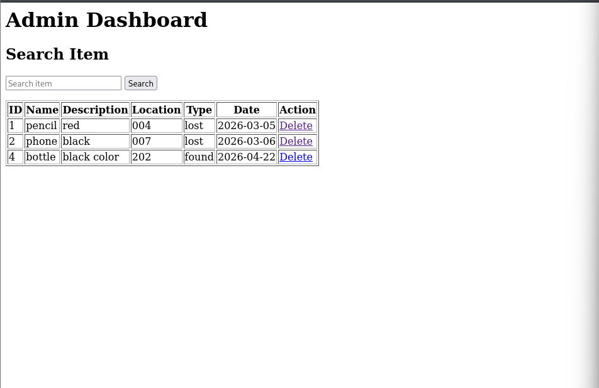

The admin dashboard displays all the stored records in a table format along with a search filter. The admin can search items and delete records once the items are returned to their rightful owners.

The delete option triggers a request to the server, which removes the corresponding record from the database. This demonstrates database management operations such as retrieval and deletion.

